ICRP - Recommendations to improve Continuous Integration and Continuous Deployment

Since ICRP initial deployment it has been difficult to synchronize developer changes through-out the development cycle. Additionally, it has been difficult to merge all change to production while maintaining the production content.

This document proposes two unique improvements to the Continuous Integration (CI) and Continuous Deployment (CD) process to make the process less burdensome.

Continuous Integration with Drupal 8

Problem #1: ICRP needs a method to allow multiple developers to add content to development site.

Solution: Use drush scripts to add/update new content. Additionally, use the drush config-export and drush config-import commands to capture configurations states.

This solution eliminates the need to export and import the entire database. It also eliminates the difficulty of export Drupal 8 Content created on production.

Method to continuously add/update content
This section describes a simple workflow to update the content of the website which can be ran as scripts. This allows flexibility and can be ran on exiting sites in stage, development and production.

Currently, there are only seven custom pages in ICRP 2.0, as of February 23, 2018.

Table 1: Current values in the node_field_data table for nodes of type page.
nid | Type | Title
2 | Page | Front Page
4 | Page | FAQ
6 | Page | About Us
12 | Page | Common Scientific Outline
19 | Page | Become a Partner
45 | Page | Historic CSO Codes
576 | Page | Password Reset

The following steps demonstrate how a developer can change the About Us page:
- Change the About Us page in a development environment and press save.
- Copy the source to a text file: Click on Edit/View Source and select all of the source code for the page. Save source code to a text file named scripts/update/2.1/about.us.html.
- Add the following line to scripts/update/2.1/update.icrp.2.1.sh
  - drush php-script update.node.drush page “About Us” about.us.html
  - The SYNTAX for this command is: drush php-script update.node.drush <node type> <node Title> <filename with new HTML source>

Using this innovative method eliminates the need to save the database and allows developers to update content to existing pages concurrently. The update.icrp.2.1.sh will be added to the composer.json post-install on under scripts section. This will ensure that all content will be synchronized across all environments.

Continuous Deployment (CD) with Drupal 8

Problem #2: Update production without exporting and important production content
Solution: Update the site using the drush config-import feature and update new content with scripts described in section Continuous Integration in Drupal 8. The one caveat to this solution is that the upgrade must be to the same Drupal 8.3.x version. Upgrading the Drupal version is a secondary process which can occur afterwards.

The new workflow to deploy to production will be a two step process. First, the production site is copied to secure staging area. The ICRP will be upgrade using the drush config-import and update new custom modules. Second step is to update Drupal to the latest, upgrade module, and update database scheme.

The important step in this new workflow is to not upgrade the Drupal Core or any modules until after merging the new development changes. This new workflow eliminates the need to export the production data and thus eliminating a difficult deployment process.

Table 2: Deployment workflow
Step | Process | Description
1 | Upgrade ICRP | Upgrade ICRP new code, configuration, and updated nodes.
2 | Upgrade Drupal Core | Upgrade Drupal Core to latest. Apply database update via drush updated.

The graphic below demonstrates the new deployment process. Upgrading ICRP and upgrading Drupal into two separate steps.
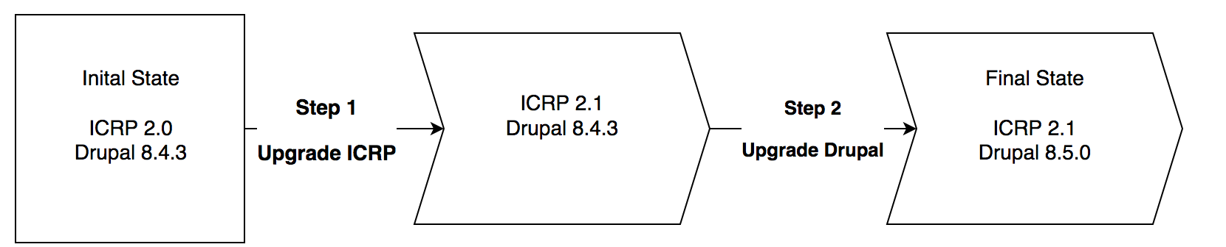

Table of Contents
ICRP - Recommendations to improve Continuous Integration and Continuous Deployment 1
Continuous Integration with Drupal 8 1
Problem #1: ICRP needs a method to allow multiple developers to add content to development site. 1
Method to continuously add/update content 1
Continuous Deployment (CD) with Drupal 8 2
Problem #2: Update production without exporting and important production content 2

